Forum - Lee is Aladdin - Panto 2015 / 2016

Author Comment
Greycat
Apr 23, 2015 - 10:24PM
It seems that Qdos Pantomime are listing Lee among their line-up of "famous faces" in panto this year - he also appears in the trailer on their site: https://youtu.be/ydAEYJkNZug
However, Lee isn't actually listed in any the casts announced so far - if Qdos haven't made a mistake, surely an announcement will be made soon? Could this be anything to do with the "nice news" Lee tweeted about recently!
Tanith Panic
Apr 24, 2015 - 4:23AM
Re: Panto 2015?
It would be lovely, as, for those of us who book for January, it's something good to look forward to after Christmas.
Greycat
May 26, 2015 - 2:06PM
Re: Panto 2015 - It's Aladdin!
It's Aladdin!

Marti Pellow, Julian Clary and Lee Mead to star in Birmingham Hippodrome pantomime

11:24, 26 MAY 2015 UPDATED 11:41, 26 MAY 2015 BY ROZ LAWS

Three stars are heading the cast of Aladdin
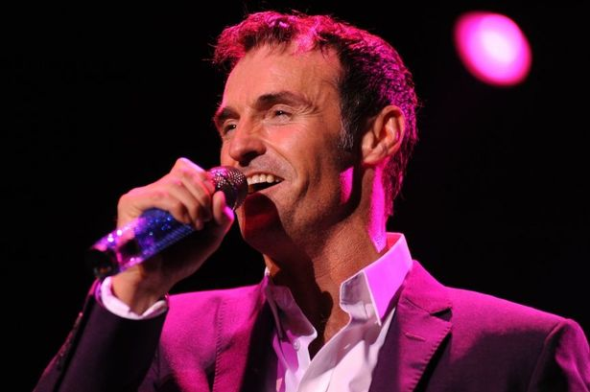
Marti Pellow
Marti Pellow, Julian Clary and Lee Mead are to star in this year’s Birmingham Hippodrome pantomime, Aladdin.
The Wet Wet Wet star will play evil sorcerer Abanazar, while Julian – who was a hit in Dick Whittington at the Hippodrome in 2010 – is The Spirit of the Ring.
Playing the lead role of Aladdin is Lee Mead, who won the BBC talent show Any Dream Will Do and then joined the cast of Casualty.
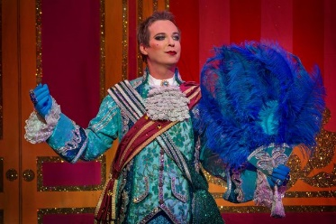Julian Clary as Dandini in Wolverhampton
Back by popular demand is comedian Matt Slack as Wishee Washee, returning for his third consecutive Hippodrome panto.
And in what will be his 30th panto and 25th year playing Dame, Andrew Ryan stars as Widow Twankey.
Audiences can expect special effects and 3D sequences which will transport them on a magic carpet ride.
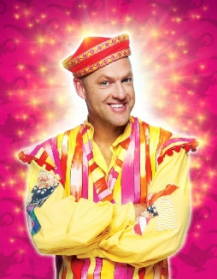Matt Slack as Wishee Washee in Aladdin coming to Birmingham Hippodrome
Aladdin, which will play to more than 100,000 theatregoers, runs from December 19 to January 31.
Michael Harrison has directed the record-breaking Hippodrome panto for the last four years and is back at the helm.
He says: “I am delighted that Marti, Julian, Lee, Matt and Andrew are starring in Birmingham’s favourite pantomime.
“Each member of our stellar cast is hugely talented and, combined with the special effects, comedy and top-drawer production values, Aladdin promises to be another unmissable Christmas show at Birmingham Hippodrome, the home of pantomime.”
Lee is heading to Birmingham this year to play the title role in Aladdin with a starry cast that includes Julian Clary and Marti Pellow. Looks good - and a long run right to the end of January so plenty of dates to choose from
Tanith Panic
May 28, 2015 - 5:25AM
Re: Panto 2015 - It's Aladdin!
I'm sure people know this already but seats are booking very fast so if you can afford to book now rather than later, go for it.
Another Liz
May 26, 2015 - 2:02PM Re: Panto 2015 - It's Aladdin!
Finally announced on Twitter by QDos and Birmingham Hippodrome, Lee is to play Aladdin in this year's panto, running from 19th December 2015 to 31st January 2016.
The po****r dates are already practically sold out!!!
Julian Clary is back as the Spirit of the Ring , with Marty Pellow as the evil Abanazer.
Greycat
May 26, 2015 - 3:43PM
Re: Lee is Aladdin - Panto 2015 / 2016
Big panto for Lee this year with a great cast.
Hope everyone who wants to go can get decent tickets!
Tanith Panic
May 27, 2015 - 5:34AM
Re: Lee is Aladdin - Panto 2015 / 2016
This is selling out very fast and the online system is not easy. 1 ticket booked so far, hope to get more by phone.

Greycat
May 28, 2015 - 12:22PM
Re: Lee is Aladdin - Panto 2015 / 2016
Here's another article about the cast for Aladdin.

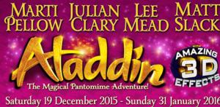
Birmingham Hippodrome Sets ALADDIN Pantomime Cast
May 26
11:15 AM2015
Print ArticleEmail Link
👤by BWW News Desk
Following last year's record-breaking production of Jack and the Beanstalk, Birmingham Hippodrome has announced another all-star cast for this year's action-packed pantomime Aladdin, which runs from Saturday 19 December 2015 until Sunday 31 January 2016.
MARTI PELLOW, JULIAN CLARY, LEE MEAD, MATT SLACK and ANDREW RYAN star in the pantomime extravaganza that delights over 100,000 Birmingham theatregoers every Christmas.
The hugely talented singer Marti Pellow stars as the evil sorcerer Abanazar. Achieving some of the UK's biggest number-one singles, Marti has regularly featured in the UK charts throughout his career, both as a solo artist and as the frontman to Wet Wet Wet. Releasing over twenty studio albums and touring the UK, Marti has won legions of fans and popularity for his distinctive and versatile voice.
In addition to his music, Marti has also starred in numerous high-profile theatre productions, including Chicago (both in the West End and on Broadway) and headlined UK tours in The Witches of Eastwick, Blood Brothers and Jekyll and Hyde. He also starred as Che in the hugely successful UK tour of Evita, which culminated in a sold-out London season at the Dominion Theatre in 2014. This month Marti and Wet Wet Wet announced they will be embarking on a 17-date UK tour to coincide with the 20th anniversary of their number 1 album Picture This.
Julian Clary has established himself as one of the country's most recognisable and popular stage and television entertainers. He has turned his hand to comedy, acting, presenting, writing and in 2012 Julian won Celebrity Big Brother. As well as his autobiography, Julian has become an accomplished novelist with a number of best-sellers to his credit. He is a hugely- popular panto performer and has headlined some of the biggest pantomimes around the UK, including Dick Whittington at Birmingham Hippodrome opposite Joan Collins in 2010. Julian plays the Spirit of the Ring.
Playing the role of Aladdin is musical theatre and television actor Lee Mead. Best-known for winning the BBC talent show Any Dream Will Do, Lee won the title role in the West End revival of Andrew Lloyd-Webber's Joseph and the Amazing Technicolor Dreamcoat to rave reviews. Since then Lee has had lead roles in Wicked and Legally Blonde in the West End, released several solo albums and toured extensively. No stranger to pantomime Lee starred as Prince Charming in Cardiff's Cinderella (2014/15) and Robin Hood in Plymouth (2013/14), both for Qdos Entertainment. In 2014 Lee joined the cast of BBC's Casualty playing the role of Ben "Lofty" Chiltern, which saw him nominated for various national Best Newcomer television awards.
Back by popular demand, Birmingham favourite Matt Slack returns for his third consecutive pantomime at Birmingham Hippodrome where he always delights audiences with his jokes and physical comedy. Recognised as one of the country's leading pantomime comics Aladdin marks Matt's 16th year with producers Qdos Entertainment. This year Matt will be Aladdin's brother Wishee Washee.
In what will be his 30th pantomime (and 25th year playing Dame), Andrew Ryan also stars as the ultimate pantomime matriarch Widow Twankey. Last seen delighting Birmingham Hippodrome pantomime audiences in the 2012 production of Robinson Crusoe opposite Brian Conley, theatregoers can expect his usual array of glamourous outfits, quick costume changes and hilarious comedy routines.
Audiences will also marvel at brand new fantastic special effects from The Twins FX, whose illusions in previous Birmingham Hippodrome pantomimes have included flying cars, terrifying dragons and a 40ft animatronic giant. For a second year running, 3D sequences created especially for the show will bring the action right out into the audience, transporting them on a spectacular 3D magic carpet ride.
Produced by Qdos Entertainment, the world's biggest pantomime producer, Aladdin is once again directed by Michael Harris on who has directed the record-breaking Birmingham Hippodrome pantomime for the last four years.
Michael said: "I am delighted that Marti, Julian, Lee, Matt and Andrew are starring in Birmingham's favourite pantomime. Each member of our stellar cast is hugely talented and, combined with the special effects, comedy and top-drawer production values, Aladdin promises to be another unmissable Christmas show at Birmingham Hippodrome, the home of pantomime."
Chief Executive of Birmingham Hippodrome Stuart Griffiths commented: "The hugely successful pantomime team of Qdos Entertainment and Michael Harris on are bringing back another terrific family show. We're delighted Marti and Lee will be joining us this Christmas and we're sure Birmingham will give a huge welcome to some of our returning favourites - Julian, Matt and Andrew. The pantomime is already selling fast so make tickets to Aladdin one of your three wishes this Christmas!"
To book tickets, grab your magic lamp, jump aboard your magical carpet and fly to the box office now!
Aladdin runs at Birmingham Hippodrome from Saturday 19 December 2015 until Sunday 31 January 2016. Tickets are on sale now priced from £14
Nice write-up for Lee in this one!
This panto has a very long run - right to the end of January. I wonder if Lee is getting leave from his Casualty commitments to do this or if he plans to have moved on by then? The album release in spring 2016 will also (presumably) take up a fair bit of his time.
Joan
Dec 8, 2015 - 4:13PM
Re: Lee is Aladdin - Panto 2015 / 2016
a lovely pic from today's rehearsals
Look in the background for our panto star
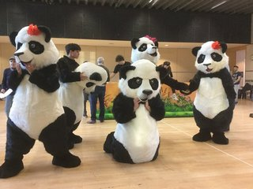
Tanith Panic
Dec 9, 2015 - 6:04AM

johartuk
Dec 16, 2015 - 6:39PM
Lee tweeted a pic of him in one of his costumes:-
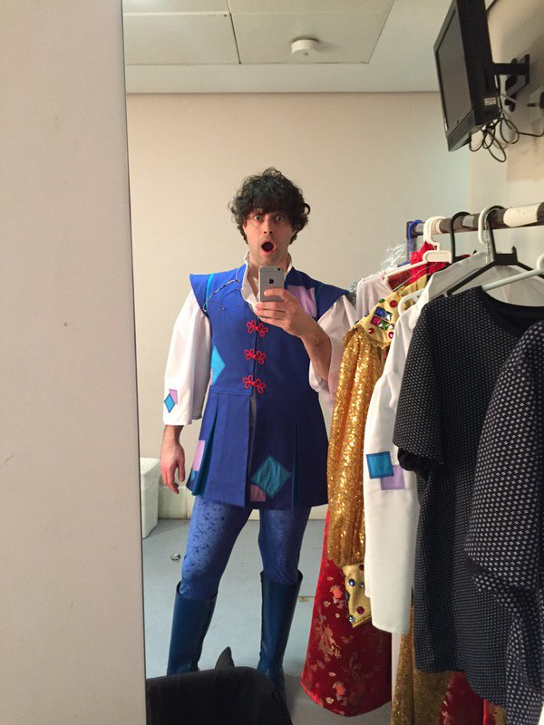
Those leggings are tight!
johartuk
Dec 18, 2015 - 3:55PM
Re: Lee is Aladdin - Panto 2015 / 2016
A photo from today's Panto Press Call:-
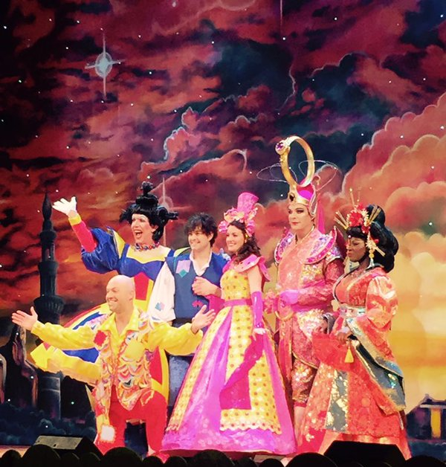
Lee's looking good...and Julian's looking interesting! I wonder how heavy that giant ring is?
johartuk
Dec 18, 2015 - 8:43PM
Re: Lee is Aladdin - Panto 2015 / 2016
Another pic from press call:-
The pyramids on the backdrop behind them remind me of 'Joseph'!
And one of Lee and Emily Shaw (who is playing Jasmine):-
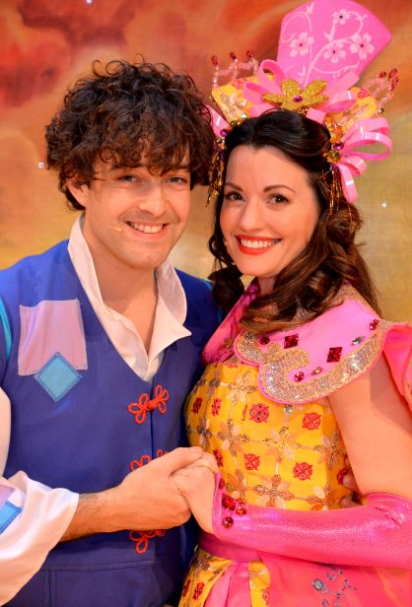
Jazzylou
Dec 20, 2015 - 2:19PM
Re: Lee is Aladdin - Panto 2015 / 2016
Hi everyone,
I couldn’t go to the first matinee of Aladdin without doing a review for you all because it was such a fun day.
I only booked my ticket last week! After the Garrick, I just felt compelled to book to see Lee’s debut as Aladdin. I managed to bag the last seat left in the front dress circle. I had row D7 and I have to say the view was perfect. I could see both sides of the stage and didn’t miss any of the show.
I was very grateful to travel with two ladies who had booked a while back and offered for me to join them. It’s so much nicer doing a longer journey on the train with someone to chat to even if it was musical seats on the way home due to the train being really packed just before Christmas. All good fun though!
We arrived into Birmingham New Street to a totally different vibe from the day we went to Lichfield. This time we were excited and able to enjoy the amazing new building. Having found the right exit we asked a very friendly local the way to the Hippodrome and he pointed us in the right direction which happened to be really close; just down the hill, under the bridge and we were there! I’ve put a few photos at the bottom of the venue. It’s large, bright and modern with a stylish interior and lots of large screens for advertising forthcoming shows. It was good to see Chitty advertised there for next year. And there is s life sized Lee which flashes up on the screen outside the theatre too.
We did a full circuit of the theatre before we found the stage door but we decided to wait just in case (as you do!) and joined by a few other ladies. We weren’t disappointed as Lee came up the road after about half an hour and we had a few words with him and wished him luck for the show. He admitted that it had been tiring doing all the rehearsals but he was excited to start.
(I will add that we also saw Julian who was smoking behind a pillar. As he went back into the doors we all said hello to him and he glanced back at us and said’ ‘morning’, in his very Julian way and went in. Got ta love him!)
We popped into a little cafe right opposite the theatre for a bit to eat after that. I can recommend the Spanish omelette, good value for money too!
And then to the show!!!
I made my way through the labyrinth of corridors (I got slightly lost at the interval!) along to my seat in the circle. It was amazing to see the theatre from there. I don’t know how many seats it has I couldn’t see any gaps by the time it started. It was very exciting to be there for the first of the season’s shows.
And here is where the review gets really tricky so as not to give anything away. It was a traditional pantomime story play e d by the best actors and given a modern twist. It was polished, professional and just like watching a West End show. Not that you would expect anything less from Qdos. The costumes are so detailed and well made. I love Julian’s stage presence and although all the stars had equal parts, he will always be the focal point and his costumes are AMAZING. Marti Pellow was also very good (I had been a bit unsure of him). He acted it straighter that Nigel Havers but I think he portray e d the character very well.
Lee was an amazing Aladdin (of course!!!) The comedy is clear and it certainly looks like he was having a very good time! There are some hilarious scenes and I think you will all like his costumes! (Insert smilie of your choice, I can’t choose one!)
Also a few mishaps which I really don’t think were meant to happen. One that stands out was when a mid scene curtain came down and caught Julian’s headdress and he had to pull it out. Being the processional that he is, he came out from behind dusting himself off and ad libbing something funny.
It has everything you would expect from a panto and as it is not a secret that there is a flying carpet I would just like to say that is was better than I could ever have imagined! Being in the dress circle gave be a really good view, perhaps better than those down below. The 3D was very good too!
After the show a few of us found ourselves back at the stage door (as you do, again) but we didn’t get lucky enough to see any of the other actors apart from Lee who came out with a few family members (awww) but was still happy to pose for a pic with a couple of girls and drove off for a break between the shows. We were able to congratulate him has he left. He was pleased we liked it.
We made our way back to the station and because we had quite a while until the train home, we did a bit of Christmas shopping in John Lewis and then had a coffee in an amazing coffee shop above the main station area. It’s an amazing place, just like a shopping centre.
It was SUCH a good day and I’m really happy that I made the effort to see it. Very very worthwhile. I think I will be looking to see if I can squeeze in a couple more trips before the end.
Enjoy the photos
Jazzylou
Dec 20, 2015 - 2:56PM

Re: Lee is Aladdin - Panto 2015 / 2016
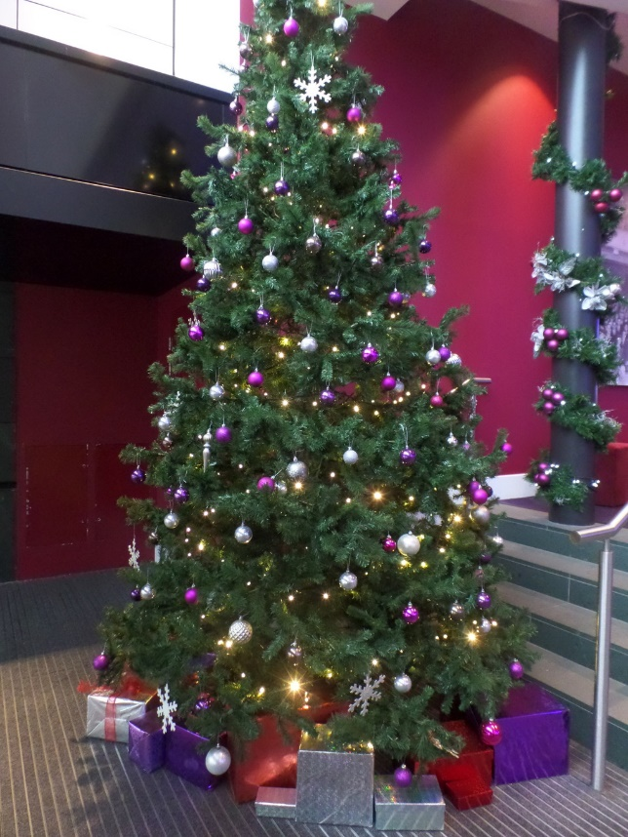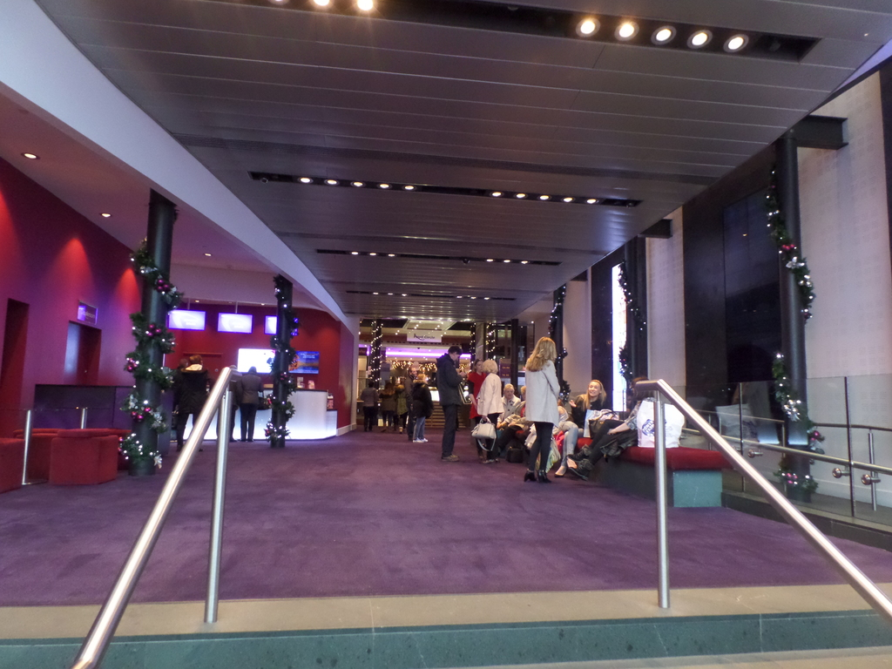
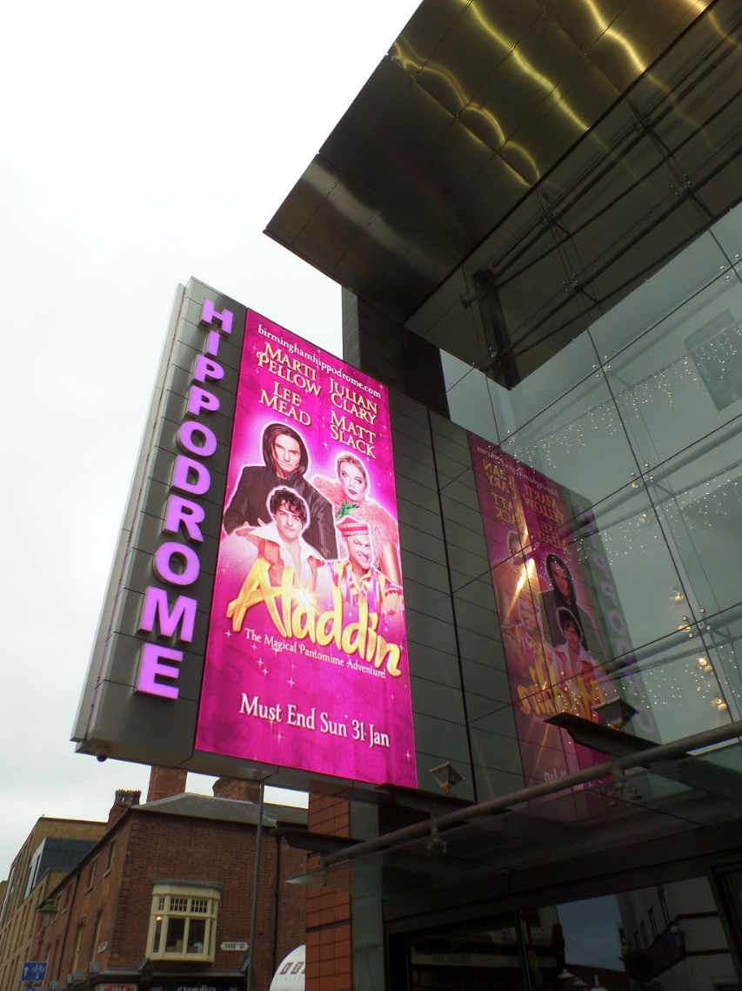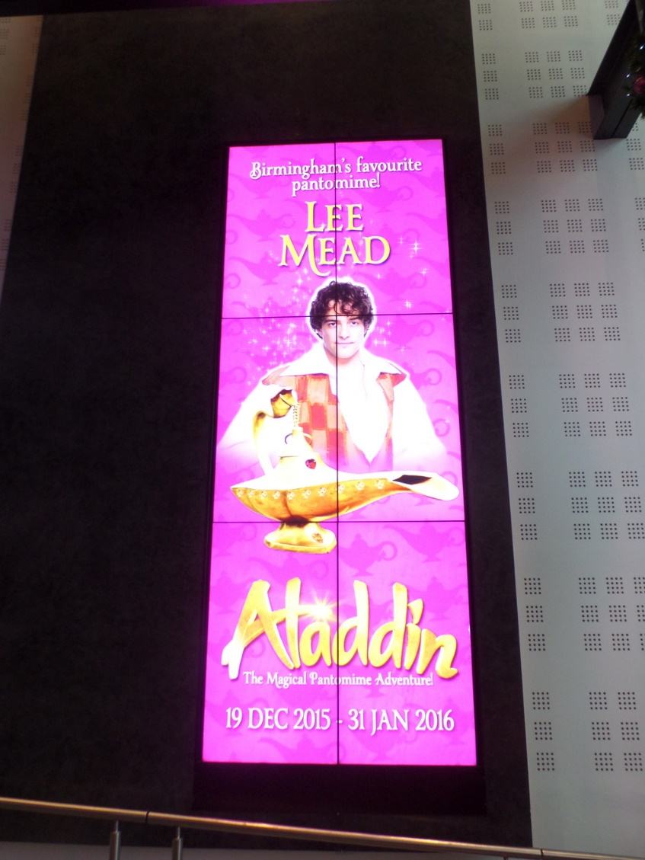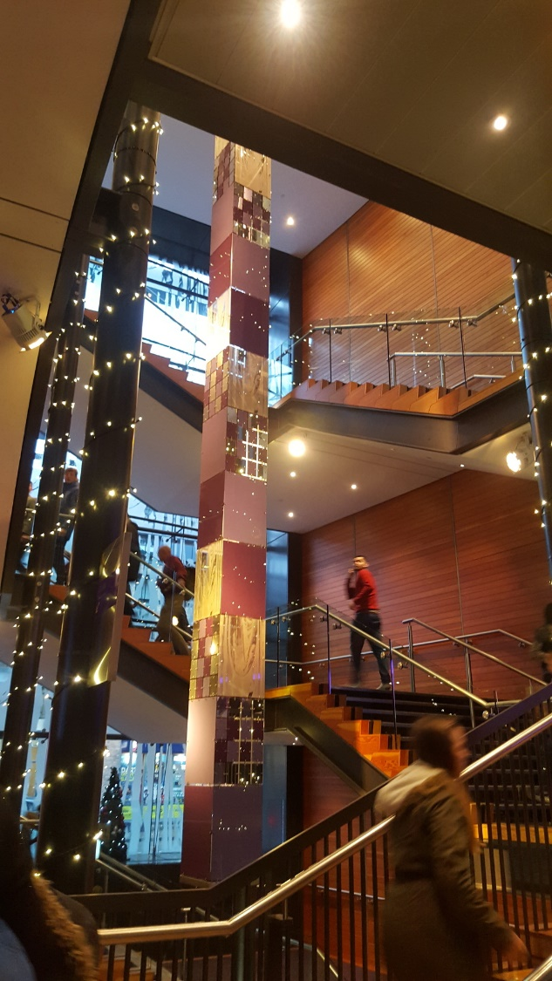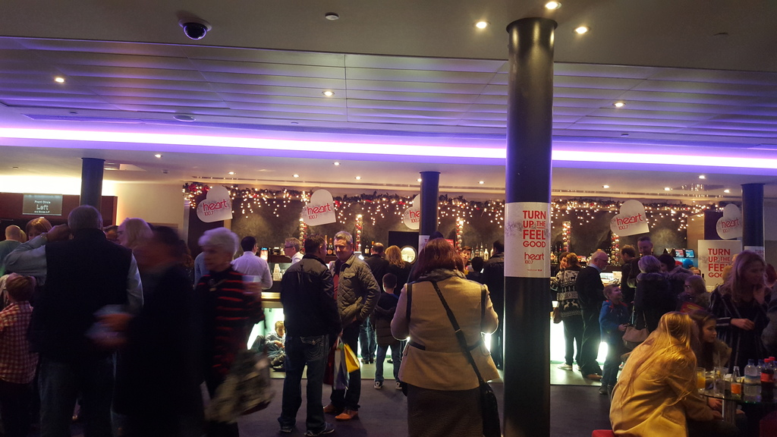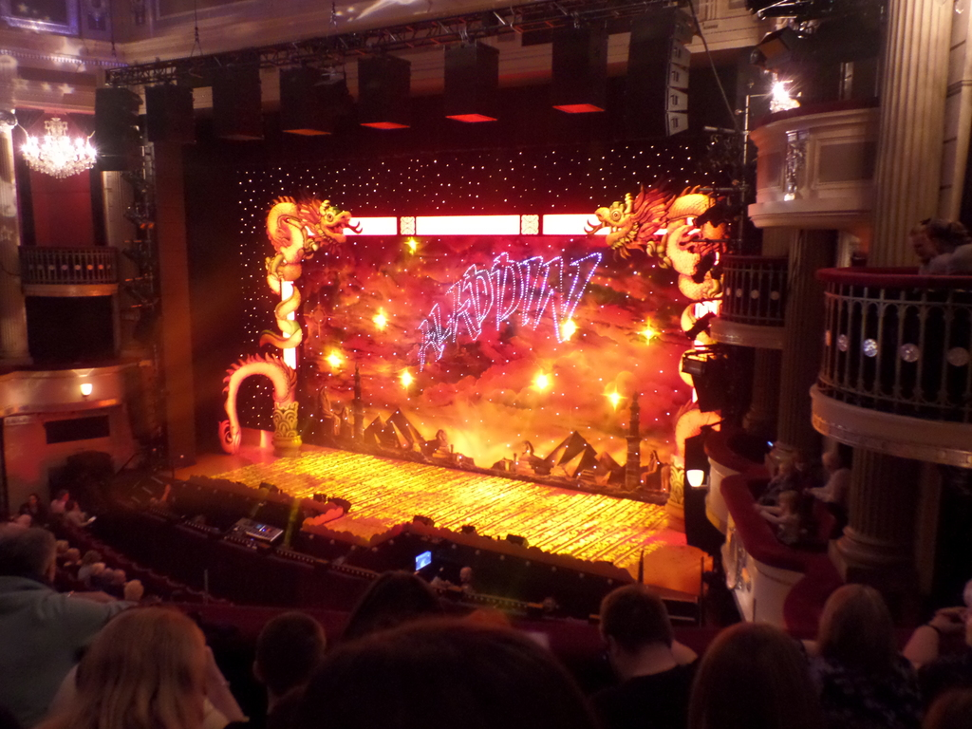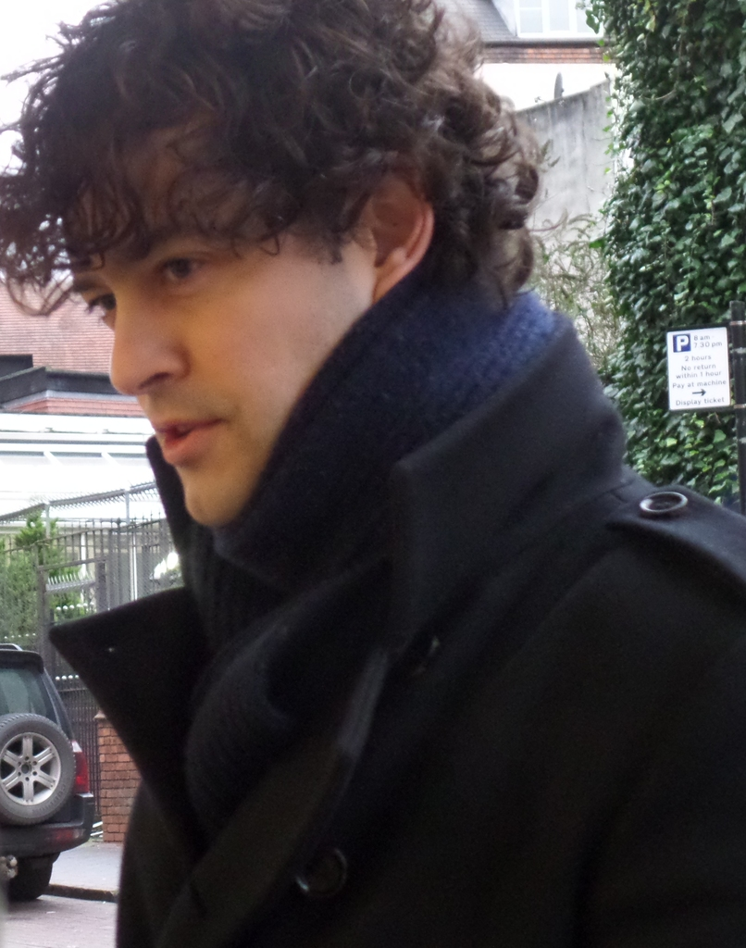
johartuk
Dec 20, 2015 - 3:57PM
Re: Lee is Aladdin - Panto 2015 / 2016
Thanks Jazzy!
LCBoniti
Dec 20, 2015 - 5:03PM Re: Lee is Aladdin - Panto 2015 / 2016
Fantastic review, Jazz - almost like being there! Thank you so much.
maggiemay
Dec 20, 2015 - 5:38PM
Re: Lee is Aladdin - Panto 2015 / 2016
Thanks Jazzy, so happy that it went well, it looks a lovely theatre
and thank you for the lovely photo of Lee.
Another Liz Dec 20, 2015 - 7:15PM Re: Lee is Aladdin - Panto 2015 / 2016
Thank you for doing the report, Jazzy - and with no spoilers too! Lovely pic of Lee, too - I love that coat! We arrived a little after you, and I wasn't exactly at my best. Apologies now if I've infected anyone with my germs for Christmas. Please be assured, everyone, I didn't get too close to Lee at the Stage Door - in fact, I even stuck down the envelope of his Christmas card with a damp cloth rather than lick it, just to be on the safe side!
It is a very impressive theatre, beautifully set out inside, with lots of space for having a pre-show drink or coffee. The lady selling programmes made us smile. When we said we were there to see Lee, she said, "He sings, you know!" We assured her that, yes, we did know. She must have thought we only knew him through Casualty! Our seats were way back in Row S of the stalls, but we had a great view due to the rake and angle of seating.
I have a confession to make. I am originally from the Brum neck of the woods (well, within ten miles or so). When I was two-and-a-half, I actually trod the boards of the Hippodrome as a Betty Fox Babe (I went to dance classes, tap and ballet )! From what I was told (I was a bit to young to remember my stage debut), I was taking part in a nursery scene, and had to push a toy dog on wheels across the stage. Unfortunately, there had been a mix up with the props, and my doggie hadn't arrived in time, so I had to toddle across the stage pretending to push nothing. Not my finest hour. You won't be surprised to hear I retired from showbiz about a year later.
But I digress. There are all sorts of different elements to this panto. Special effects galore - 3D, flying carpet, monsters, goodies (Aladdin), baddies (Abanazar), dames (Widow Tw an key), comedians (Wishee Washee), heroines (Princess Jasmine) .... and .... Julian There were bits I absolutely loved (i.e. any scene with Lee in it, one particularly hysterically funny one) and a few bits I wasn't so keen on, but overall a great panto. I'm sure after another visit or so (cough cough!) I will love it 100%!
We were also blown away by New Street Station. We have travelled via New St on numerous occasions to Lee concerts etc, and for the last few years it has been something of a shambles. Now it's an amazing place. I think we may have to pay a call to John Lewis on another occasion!
Incidentally, if you go to Birmingham Hippodrome FB page, they have lots more lovely photos from the press call the other day.

LCBoniti
Dec 21, 2015 - 12:59AM
Re: Lee is Aladdin - Panto 2015 / 2016
Oh, ALiz, you had me chuckling over your stage debut.
acer Dec 21, 2015 - 1:20AM Re: Lee is Aladdin - Panto 2015 / 2016
Hi Jazzy thanks for great review as always and pic's you did very well getting such a good seat especially getting it so late! the gods were smiling on you!
cheers acer
Tanith Panic
Dec 21, 2015 - 6:14AM Re: Lee is Aladdin - Panto 2015 / 2016

Thanks for the great and spoiler-free reviews.

Joan
Dec 21, 2015 - 9:37AM Re: Lee is Aladdin - Panto 2015 / 2016
Thanks Jazz for your review.
glad that you were able to get such a good a last minute seat.
I'm very excited about this panto. It sounds amazing.
ALiz I am also originally from Brum. though I left there when I was in my early 20's. (many years ago)
I love Birmingham. especially at this time of year with the German Xmas market and the hustle & bustle of shoppers everywhere.
I can't wait to have a proper look around the new station. I did have a little look on my way home from Litchfield. But as you can imagine I wasn't really in the best of spirits that day.
I have to wait until after Christmas to see Lee in Panto this year
I won't be able to go to the stage door as I will be with family.
But I am really looking forward to seeing the show after reading your reveiws
Jazzylou
Dec 21, 2015 - 10:13AM
Re: Lee is Aladdin - Panto 2015 / 2016
It's definitely worth waiting for Joan.
A Liz, thank you for the heads up about the facebook site for the Hippodrome, I hadn't seen those other photos. Great stage story I hope you are feeling better.
Thanks for your comments on my review. Looking forward to reading more when they come in.
Happy Christmas all

johartuk
Dec 21, 2015 - 8:39PM Re: Lee is Aladdin - Panto 2015 / 2016
Loving this - Lee tweeted an 'Interval Selfie':-
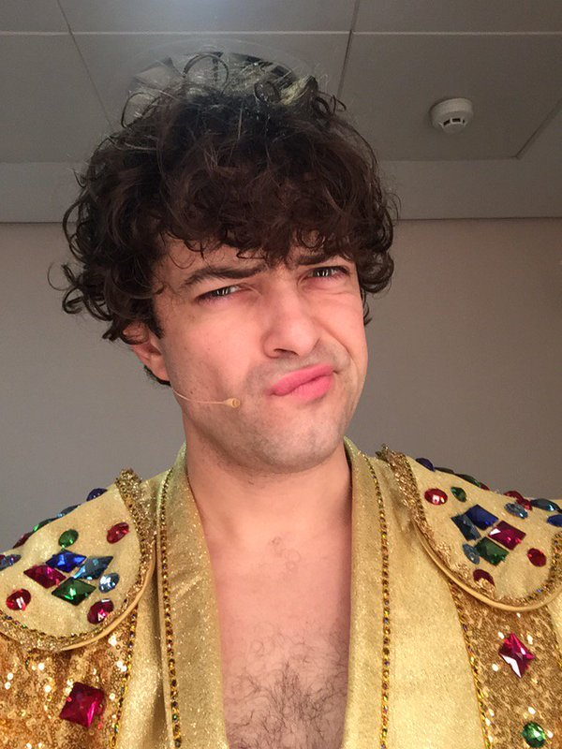
He really has an expressive face!
Jazzylou
Dec 21, 2015 - 9:48PM
Re: Lee is Aladdin - Panto 2015 / 2016
Hmm a few people have mentioned his face. I didn't it notice at first He's dropped a spoiler there, and I was trying hard to keep it quiet!!!
AngelRose
Dec 22, 2015 - 4:43PM
Re: Lee is Aladdin - Panto 2015 / 2016
Just to let you all know there are some great new (spoiler filled) pics on the Birmingham Hippodrome Facebook page
AngelRose
Dec 23, 2015 - 12:47AM
Re: Lee is Aladdin - Panto 2015 / 2016
The first review I've seen: LINKY THING
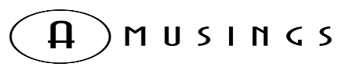
ALADDIN (Pantomime) - THEATRE REVIEW
December 23, 2015

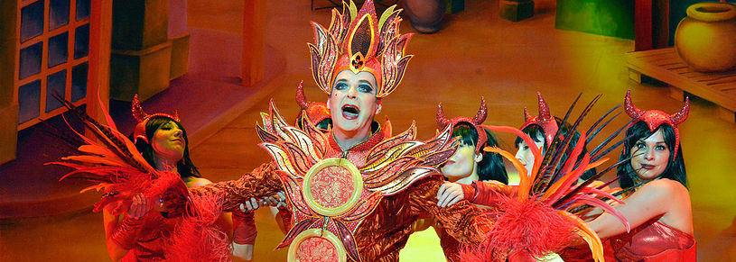
A L A D D I N
¯¯¯¯¯¯¯¯¯¯¯¯¯¯¯¯¯¯¯¯¯¯¯¯¯¯¯¯¯¯¯¯¯¯¯¯¯¯¯¯¯¯¯¯¯¯¯¯¯¯¯¯¯¯¯¯¯¯¯¯¯¯¯¯¯¯
Birmingham Hippodrome (Pantomime)

★★★★★
THEATRE | Kyle Pedley
CLARY & SLACK MAKE ALL YOUR PANTO WISHES COME TRUE...

“All that’s left for me to say is you’ve been... you’ve been... well, you’ve been, that’s the important thing.”

It’s a perfectly pitched, characteristically dry close from Julian Clary as he brings the Birmingham Hippodrome’s 2015 panto of choice, Aladdin, to a close, bedecked in another outrageous, gloriously over-the-top costume creation that would have Lady Gaga reaching for her meat dress in envious rage. Not a million miles away, at the City’s Barclaycard Arena, Bradley Walsh, Paul O’ Grady and friends have stolen away the Hippodrome’s previous tagline of ‘the UK’s biggest panto’ with their colossal take on Cinderella. However, whereas that overblown, over-produced spectacle is simply too big for its own good, the magic of panto drowned in such an overly expansive venue, Aladdin at the Hippodrome grants the big three panto wishes in style - it’s big, it’s fantastic to look at and, crucially, it is very, very funny.

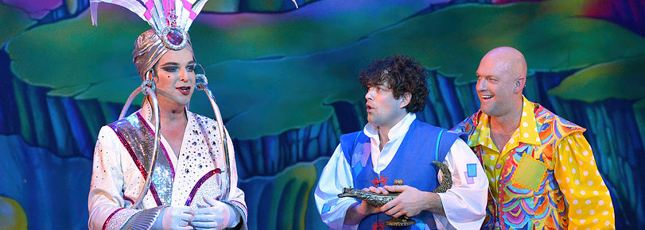
Much of the humour this year round comes from the returning Matt Slack as Wishee Washee, a comedic tour-de-force whose humour runs practically the whole gamut - there’s physical slapstick in there, impressions, wordplay, plenty of the typical local ribbing (the most frequent foils being nearby Dudley and Black Country) and the energy, timing and execution of them all is faultless. On the evening reviewed, Slack audibly suffered from a hoarse voice, with Clary at the end clarifying he will soon be ‘sucking on a Fisherman’s friend’ for those concerned, and yet his energy levels never dipped throughout. Seeing that Slack is once again returning for panto duty in 2016 for the Hippodrome’s production of Dick Whittington comes as no surprise - he is almost incomparably good at this panto lark and long may his appearances at the Hippodrome continue.

Equally funny, however, is the aforementioned dry wit and hilarious side-sniping contempt of Julian Clary. If, in last years review of Cinderella at the Wolverhampton Grand, I noted that Clary seemed somewhat tired, and dare I say it, coasting, he is back on terrific form here in Birmingham. From his endless supply of double entendres to blisteringly poking fun at the ludicrousness of practically everything throughout, the energy is definitely back and Clary, as the ‘Slave of the Ring’ (trust me, it’s milked for all it’s worth) definitely brings an edgier, wittier bite to the show, and an extra flavour to the funny that the adults in particular will find both welcome and hilarious. Plus, the sight of him re-enacting Beyonce’s ‘Single Ladies’ dance routine or Johnny Cash’s ‘The Ring of Fire’ is too barmily wonderful to describe.

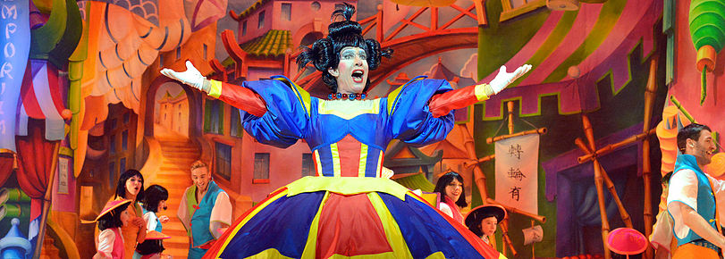
Rounding out the cast, Lee Mead is a handsome and dashing Aladdin, getting to showcase his powerful, sumptuous voice throughout, whilst there is naturally plenty of light-hearted fun made of his musical theatre background, particularly his rise to fame playing Joseph. The ever-reliable Landi Oshinowo makes an appearance as a stern Empress, her powerhouse vocals given the chance to shine early on, whilst Andrew Ryan is the perfect pantomime dame, wisely pitching his Widow Twankey at the younger audience (with Clary dominating the more adult material). Ryan’s tag-teaming and comedy pairings with Slack are particularly fun - such as an extended ‘apple’ watch gag that I shan’t spoil with specifics, and a war of wordplay between the pair and Marti Pellow, featuring plenty of laugh-out-loud corpsing. Speaking of Pellow, he makes his panto debut with gusto, surprisingly dramatic and extremely effective as villain-of-the-piece Abanazar the sorcerer. Pellow plays his part relatively straight, again well judged given the roster of comedic talent that bounce off of him, and he certainly makes for a fantastic, boo-able pantomime villain. Pellow gets a couple of musical set pieces of his own, his inner pop star momentarily taking front and centre as the character croons sinisterly about himself (naturally).

This being a QDOS pantomime, it is unsurprising that the standard of production on display here is nothing short of superlative. This is panto writ-large and done right, from West End-worthy staging, costume and lighting design, an exciting 3D video sequence which elicited plenty of jumps and shrieks from the audience (3D glasses provided), an extended acrobatic slapstick spectacular through to a plethora of one-use practical set pieces and special effects which eclipse anything the competition offers. To go into too fine a detail would be to ruin the show, but you know when you get an extended cameo appearance from a fully sized and operational King Kong within the first ten minutes and a full working flying carpet sending Matt Slack and Julian Clary out over the audiences heads before the interval, this is a show which is sparing no expense and pulling no punches in the audio-visual design department. Once again, the Hippodrome firmly cements itself as the go-to destination this Christmas and New Year for all your pantomime needs.

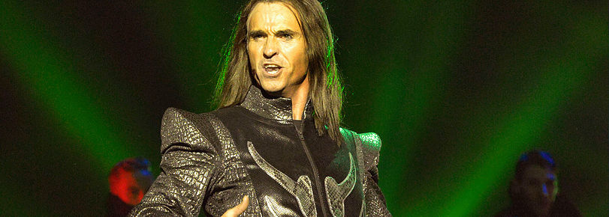

Another visually stunning, exciting, hilarious and masterfully executed production, Aladdin is a very easy recommendation, and whilst it is a trifle old hat and glib to proclaim how it offers something ‘for the whole family’, nowhere is that more true than here. Within the immediate vicinity of my seat, there were audience members from (very) young children through to pensioners all equally doubled over in laughter and swept along on the joyous, whimsical ride, and nobody can deny the scope and attainment of what QDOS once again bring to the Hippodrome stage. So clap your hands and rub your ring in excitement, for all of your panto wishes have been granted - Aladdin is a delight of a magic carpet ride for all ages and it doesn’t take a genie-us to figure out that it’s an absolute must-see this Christmas.

Now excuse me, I need to go lie down and polish my lamp to recover from all those puns.

LCBoniti
Dec 25, 2015 - 10:56PM
Re: Lee is Aladdin - Panto 2015 / 2016
Jane W has done another amazing review which we have added to the website. Check out our new "Aladdin Panto Reviews" page:
If you have one you would like us to add to the Aladdin reviews (spoiler or non-spoiler - we will let people know), just email us. We love to have your partici-pation. It's what keeps the website fresh.
Besides, some of us (OK, moi! ) are stuck far away and will not be there in person so we appreciate all the reviews we can get.
Greycat
Dec 30, 2015 - 10:18PM
Re: Lee is Aladdin - Panto 2015 / 2016
Belated thanks to Jazzylou, ALiz and Jane W for the reviews and lovely photos!
Thanks also to AngelRose for the review from Amusings. From what I have seen, the critics seem to like the panto
I also found this review: LINKY THING

Home » Review Zone » Theatre Review – Aladdin Birmingham Hippodrome

Theatre Review – Aladdin Birmingham Hippodrome
by Mums Club Admin
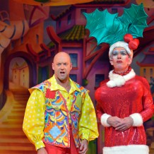

Aladdin at Birmingham Hippodrome is a cry-laughing delight of non-stop antics
Other than the big day itself, Panto is possibly the biggest part of our family Christmas. It’s not about seeing the biggest venue, or even the biggest stars, we do big, small and in-between venues and love them all for different reasons; smaller theatres can often produce a wonderful up close and personal home-made experience, whereas the larger productions who attract the bigger names can provide a much grander evening out.

This year, Aladdin at the Hippodrome took Panto to a whole new level.
I am sincerely envious of anyone who hasn’t yet been so I won’t give away the details away for fear of ruining it for anyone planning a trip and for those who have been already, you’ll know what I mean!
The opening scene scared the bejeebers out of us, what with the baddie Abanazar played by Marti Pellow, lead singer of the 80’s band Wet Wet Wet, supported by darkness, spooky lighting and thundering sound effects, oh and the humongous gorilla! He was truly frightening as he introduced the plot, and when a group of gorillas came pounding onto the stage and down the steps, let me tell you being sat on the end of the 4th row was terrifying! Loved every minute!
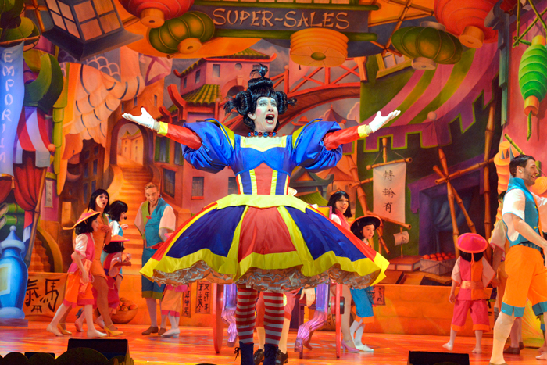
Don’t worry though, Wishy Washy, Aladdin’s hilarious brother soon appeared on stage, and normality resumed with the Panto antics we love in all its glory. Matt Slack, the Birmingham Panto regular played a marvellous Wishy Washy and when joined on stage by his Mother, the Widow Twanky played by Andrew Ryan the scenes became so hilarious even other cast members on stage break their composure, seeing even the glaring Abanazar break into giggles is fantastic, and a relief too because I was quite frightened of him.
Julian Clary was his usual and camp self, with fantastic costumes and a series of his double-entendres, he just about kept it respectable although a few less quips might help parents navigate the ‘I don’t get it, what’s everyone laughing at?’ questions from the kids.
Lee Mead (Lofty in Casualty) is wonderful, belting out a number of solo’s – it’s clear to see why he won the Any Dream Will Do competition in 2007 and it was great to see him live. After asking my 10 year old which was his favourite scene, the duet with Princess Jasmine came out on top – mainly because the romantic love song was is interrupted by Wishy Washy and quickly turned into the best slapstick scene since Benny Hill. My son had trouble catching his breath from laughing so hard.
And the hilarity didn’t stop, mainly thanks to Matt Slack’s Wishy Washy; from impressive and long tongue twisters, to a quick rendition of the ‘epic’ so money supermarket advert.
Princess Jasmine was joined by the Acromaniacs who performed impressive stunts on stage and the kids from the Birmingham Stage school were just as impressive.
The special effects were like nothing we’ve seen before in one show, a number of scenes involved spectacular mechanical elements, from King Kong in the opening scene, a giant snake later on, the fabulous Brummie Genie and the flying carpet which stunned the audience by flying out over the first few rows. Amazing effects.
But not only that, after the interval, through the magic of 3D we joined Aladdin and his pals as we all flew off to rescue Princess Jasmine! With the aid of 3D glasses the journey was full of danger with carious creatures coming for us, it was utterly breathtaking, with the audience gasping, whooping and yelling out at various times too.
In all the Panto’s we’ve been to, I have never seen my son so animated, crying with laughter a number of times and we spent the car ride home reliving it all. A thoroughly awesome production from all involved.
Aladdin at the Birmingham Hippodrome runs until Sunday the 31st January 2016.
Sounds as though the cast are enjoying themselves and I'm sure the fun will only develop further as the run goes on - I am jealous of everyone with trips to Birmingham planned
LCBoniti
Dec 31, 2015 - 2:38AM
Re: Lee is Aladdin - Panto 2015 / 2016
Another two reviews on the Aladdin Panto Review page - and a few photos. May be some minor spoilers so don't look if you don't want any at all.
But for those of you who can't wait . . . or can't go . . . *phoar* meadaholics panto page
johartuk
Dec 31, 2015 - 2:54PM
Re: Lee is Aladdin - Panto 2015 / 2016
Tight white breeches - reminds me of Fiyero!
Joan
Jan 4, 2016 - 4:06PM
Re: Lee is Aladdin - Panto 2015 / 2016
another lovely review by Alex Bellfield + VIDEO

Review Pantomime Birmingham Hippodrome 2016 Aladdin
Enjoy Celebrity Radio’s Review Pantomime Birmingham Hippodrome 2016 Aladdin….

OK boys and girls, this one is easy – the Birmingham Hippodrome 2015/2016 production is simply the best pantomime in theatrical history!
Seriously, Aladdin has the perfect mix of music, light, sound, spectacular production pieces, big illusions,special effects and double/triple entendre!
With stunning music and dance numbers, beautiful costumes & endless nob gags – this is the perfect recipe for the ideal family night in the theatre

There’s truly something for everyone. This a 5* masterclass in Live entertainment.
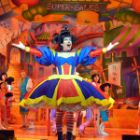 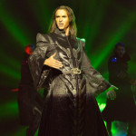 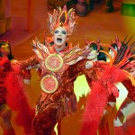 Exclusive Audio / Video Review Via YouTube: You could argue this show would be amazing without a Star cast. It’s seamlessly written and moves along at lightening speed with killer gags. The Celebrity highlight in the 2015 production was Julian Clary’s sneering, dismissive put-downs and regular nob gags. His costumes are fabulously sensational! Only JC could keep one tawdry ‘ring’ gag going for over 2 hours without it getting tired. Matt Slack, despite being last on the poster, is first to be re-booked for 2016/2017! He has the BIG personality driving the entire show. He’s effortless and the epitome of a Panto Star.
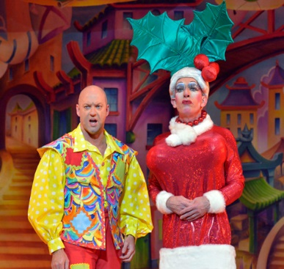
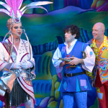 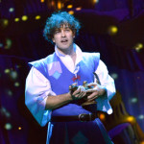 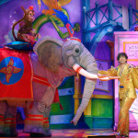 Also, Lee Meads voice was a true delight. This man is a rare ‘reality’ Star winner who has mega talent. He lets his voice shine and allows Julian to relentlessly mock his squeaky clean ‘musical theatre’ persona.Qdos are the genius’ behind most of the countries biggest Pantos. Michael Harrison is at the helm of their biggest showstopper in Brum.He masterfully mixes the traditional gags and ‘bits’ with massively expensive Showbiz spectacular & a fabulously produced 3D segment in Act 2.
Kudos to Qdos for re-hiring Andrew Ryan’s perfect Widow Twankey. Epitome of Dame voice, timing, delivery and shenanigans.
Marti Pellow as Abanazar was popular with his fans and adequate in the role.
This Panto is the best by a mile mostly down to numbers. It attracts over 100,000 a year paying £35+ per ticket. This gives the privilege the best of everything from talent to illusions.
With nods to the tradition throughout, “Oh no they don’t” etc, there’s also more risqué innuendo from Clary’s acid tongue for the Dad’s.

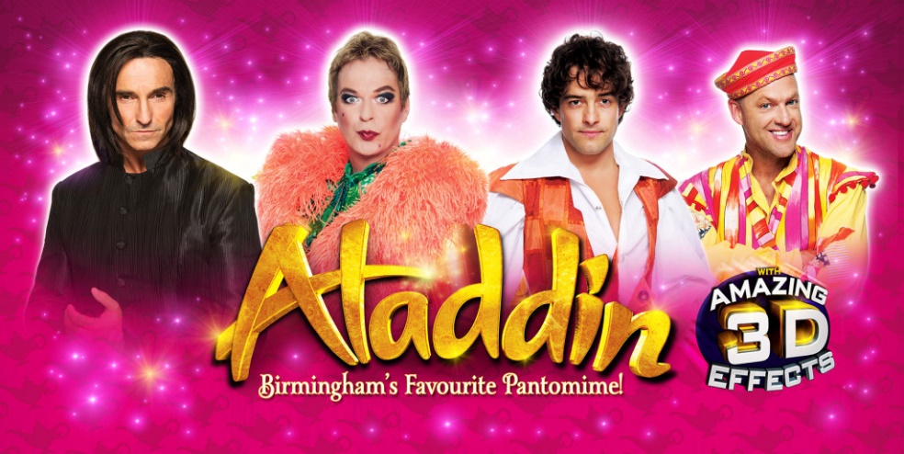
This show has class, charm, cheekiness and cuteness via Panda’s & baby elephants.
You can see your investment in front of your eyes. So rare outside of the West End and Broadway.
I guarantee you’ll leave feeling you had absolute value for money. In fact this glamour-fest is a bargain!
Congrats all of the above – a masterclass in Panto.
Aladdin in Birmingham is the benchmark for anyone who thinks they can do Pantomime better!
Review by Alex Belfield for Celebrity Radio 3rd Jan 2015.

Celebrity Radio by Alex Belfield
https://youtu.be/YhHzJX5IzJ4
Johartuk Jan 4, 2016 - 5:01PM Re: Lee is Aladdin - Panto 2015 / 2016
Great review! I especially like the bit about Lee being "...a rare 'reality' star winner who has mega talent..." very true!
johartuk
Jan 5, 2016 - 3:40PM
Re: Lee is Aladdin - Panto 2015 / 2016
Lee tweeted this pic from his dressing-room - very blingy!
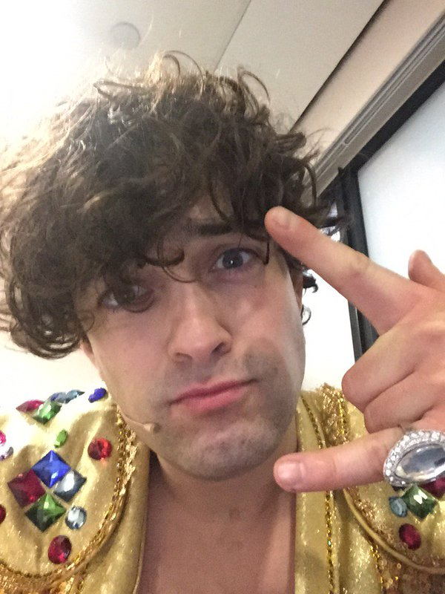
Greycat
Jan 14, 2016 - 10:37PM
Re: Lee is Aladdin - Panto 2015 / 2016
I see that Lee's old ADWD vocal coach popped in to see the panto yesterday!
@zoetyler: @leemeadofficial @TheMattSlack Laughed and laughed some more - Loved it thanks Lee! Sounding ace, hugs X Go see Brum panto fellow brummies

johartuk
Jan 14, 2016 - 11:10PM
Re: Lee is Aladdin - Panto 2015 / 2016
Nice tweet.
johartuk
Jan 20, 2016 - 12:21PM
Re: Lee is Aladdin - Panto 2015 / 2016
Loving this - a interview backstage with the cast of Aladdin:- https://youtu.be/d-aT70a43SI
So Lee's the least punctual!
Ruthie
Jan 20, 2016 - 4:04PM
Re: Lee is Aladdin - Panto 2015 / 2016
And biggest giggler
A fun interview.
Joan
Jan 22, 2016 - 9:30AM
Thanks Jo for posting the link to the backstage with the cast radio interview.
only 9 more days before the last performance
how many Lee fans are going to be there for the last day?
Tanith Panic
Jan 23, 2016 - 5:53AM
Re: Lee is Aladdin - Panto 2015 / 2016
Me, weather permitting. (I have to say that, it's my lucky charm at this time of year.)
Greycat
Jan 31, 2016 - 9:52AM
Re: Lee is Aladdin - Panto 2015 / 2016
May everyone going to the last shows today have a fabulous time!
Shame that, according to his tweets, Lee has caught a cold right at the end of the run but hopefully it won't affect him too much. At least he can (hopefully) relax for a bit after this before he has to start promo for the album release and prepare for the Pheasantry gigs.
Joan
Feb 2, 2016 - 10:05AM
Re: Lee is Aladdin - Panto 2015 / 2016
it was lovely to see so many of you in Birmingham over the weekend.
Tanith I was so pleased that you made it
I will try to do a review later.
I am finding it a bit hard to settle down to work today.

Jazzylou
Feb 2, 2016 - 10:09AM
Re: Lee is Aladdin - Panto 2015 / 2016
A passing gift.
Lee was amazing in the last two shows. His cold could be heard in his voice but it didn't stop his performance and he still hit the high note at the end of Act 1 which is a bit I came to love. I can still hear it in my head.
We had press-ups in the matinee which was rather enjoyable
He was very upset about Terry Wogan as he got out of the taxi. He had only just heard the news. But it didn't' let his performance down, the professional that he is!
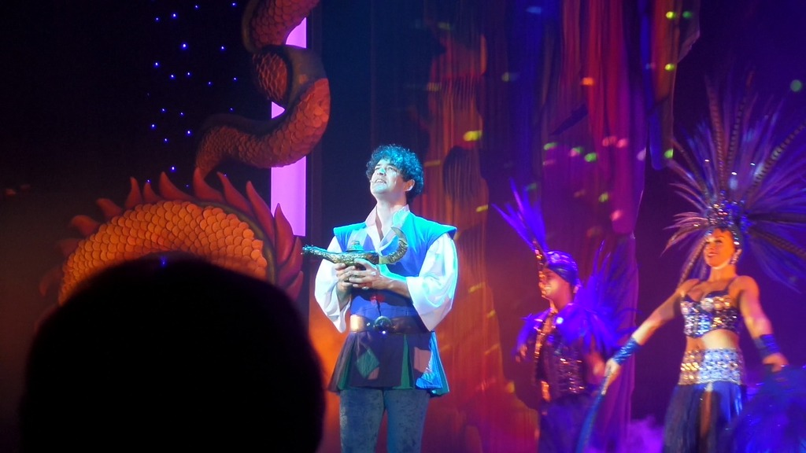
Joan
Feb 2, 2016 - 10:15AM
Re: Lee is Aladdin - Panto 2015 / 2016
That is a lovely photo Jazzy
Thank you for that treat.
I wasn't in a position to take pics but here is a little gem that I did manage to get:
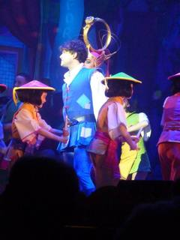 Any Dream will do

Greycat
Feb 2, 2016 - 10:21PM
Re: Lee is Aladdin - Panto 2015 / 2016
Thanks for the comments and photos Jazzylou and Joan!
Very nice
I'm looking forward to your review when you get a chance Joan. Sounds as though the panto had a good send-off.
LCBoniti
Feb 3, 2016 - 5:15AM
Re: Lee is Aladdin - Panto 2015 / 2016
Love the photos - thanks so much for sharing!
For anyone who was not able to go to the panto - and for those who did but would like to relive it - Jane W has done a fantastic review called 'Aladdin - The Full Story'. New photos as well. Check the website homepage for the link.
One photo in particular will be worth reading the whole review . . . let's just say, Lee looks particularly HOT in red . . .
Tanith Panic
Feb 3, 2016 - 6:44AM
Re: Lee is Aladdin - Panto 2015 / 2016
Jane, your final review is wonderful and those photos are a joy to look at.
Another Liz
Feb 3, 2016 - 3:52PM
Oh my goodness gracious me! I never thought I would ever see THAT saucepan again - oh how I miss it already!
Thank you so much, Jane, for your wonderful review!
Cassie
Feb 3, 2016 - 4:26PM
I loved reading that review Jane. Thank you. What a lot of detail (and that's just the saucepan pic!!)
I have a couple of SD pics which I will try to post now.
Cassie
Feb 3, 2016 - 4:37PM
Re: Lee is Aladdin - Panto 2015 / 2016
2 SD pics from Sunday. Cropped from waving camera in the air shots!
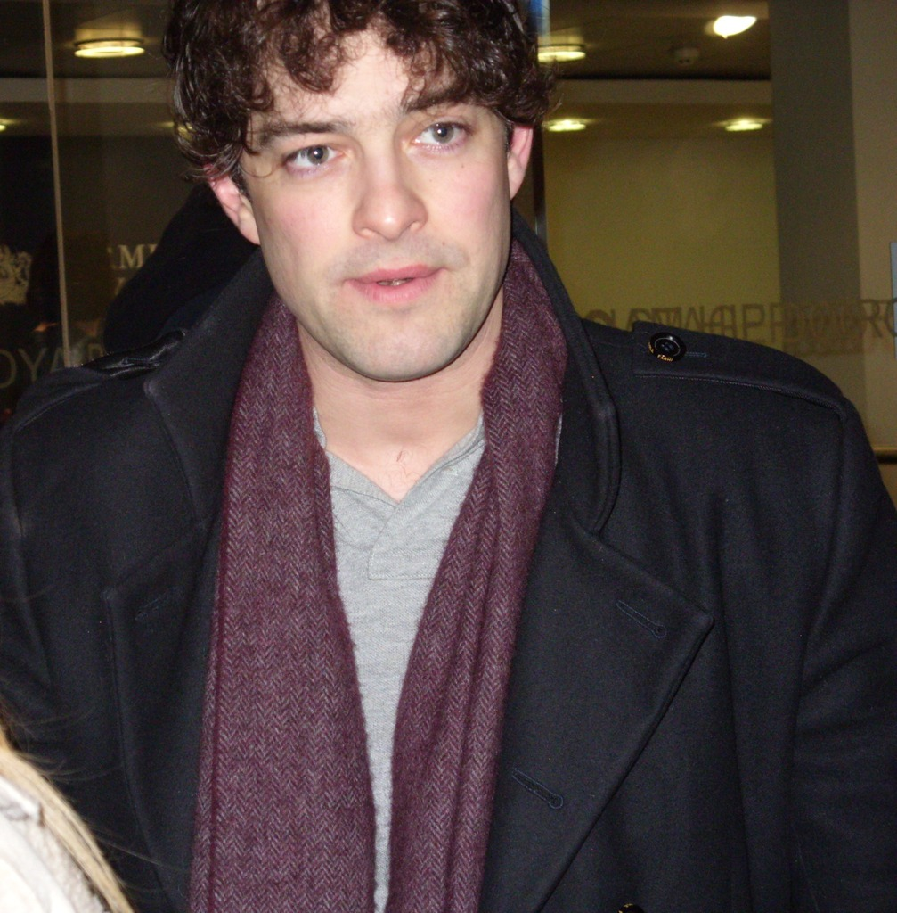
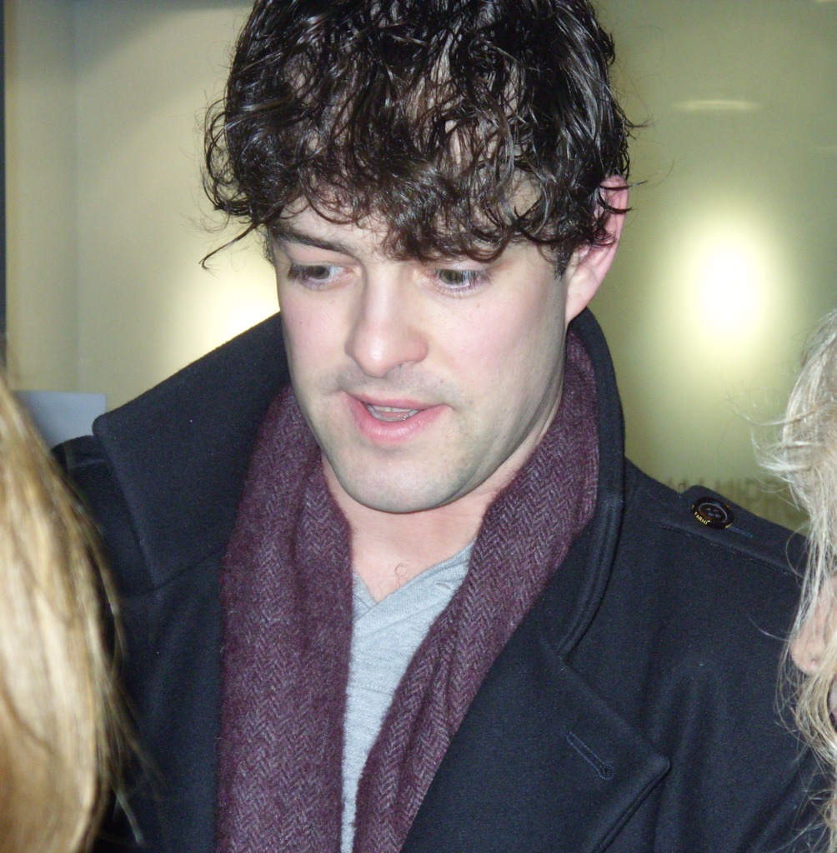
By the way, so lovely to talk to so many lovely people on Sunday.
Joan
Feb 3, 2016 - 10:22PM
Re: Lee is Aladdin - Panto 2015 / 2016
Thanks for the SD pics Cassie
It was lovely to chat with you at the stage door.
I may have a couple of SD pics. I will have a look.
Loved reading Jane's review & I love the pics
johartuk
Feb 3, 2016 - 11:20PM
Re: Lee is Aladdin - Panto 2015 / 2016
Great review Jane!
Tanith Panic
Feb 4, 2016 - 6:30AM
Re: Lee is Aladdin - Panto 2015 / 2016
These are lovely stage door photos. I was a little sad (but it didn't bring me down off the cloud I was on!) because I wanted to watch Lee but not to talk to him as I'd had my moment the previous evening (thanks to Jane for the lovely photo.) So I hid at the back, and hid a little too
Joan
Feb 4, 2016 - 9:28AM
Re: Lee is Aladdin - Panto 2015 / 2016
I only managed to see Lee at the SD on the very last night.
I wanted to get him to sign SunnyMeads birthday card
He did of course & she was very happy.
Thanks to all of you that signed her card
Here's a couple of my SD pics. I'm loving the shorter hair.
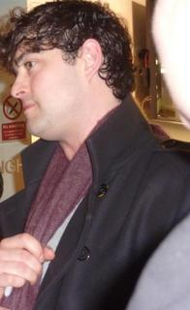 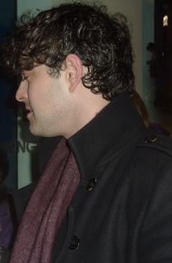
Ruthie
Feb 5, 2016 - 4:39PM
Re: Lee is Aladdin - Panto 2015 / 2016
Lovely photos and reviews - thanks.
Special thanks to Jane for her great review, and whoever it was that managed to get the photo of Lee in his "Little Jimmy Brown" costume- priceless. My grandad used to sing that song to me, I used to cry at the end.
Like Jane, I was rather bemused at how King Kong *****d in, and a few other bits seemed to be stretching it a bit, but hey - its allowed, its panto. I thoroughly enjo*** the performances I saw. I was rather hoping Lee would sing "A Whole New World", but I loved the songs he did sing.
Tanith Panic
Feb 10, 2016 - 7:03AM
Re: Lee is Aladdin - Panto 2015 / 2016
Sorry I never reviewed this time, but Jane's brilliant review and photos eclipsed anything I could have posted or added. All I can add is that it was brilliant, and made a very bad outward journey worthwhile!

Another Liz
Feb 10, 2016 - 10:33PM
I can't really add any more to the reviews already posted. We saw Aladdin *ahem* a few times, with seats everywhere, from the front row to the dizzy heights of the dress circle, which had such a steep rake, but each had its own charm.
But, true to form, the WJs on tour had their 'it could only happen to us' moment. We had gone back to the bar of our hotel and walked into what, if it had been a musical, could only have been 'Rocky Horror' ('Sweet Transvestite' ... I should add, they weren't in stockings & suspenders, just in frocks, but you get the picture ....)
Joan
Feb 11, 2016 - 4:22PM
Re: Lee is Aladdin - Panto 2015 / 2016
you ladies always stay at the very best places don't you?
Curly Liz
Feb 11, 2016 - 6:01PM
Re: Lee is Aladdin - Panto 2015 / 2016
LOL! A/Liz...could only happen to us Joan, it's almost as if we 'order it up'!!!...
What a lovely thread this is. Must admit I really did enjoy Aladdin what a huge production...but I think my overall favourites are still 'Cinderella' and 'Robin Hood'...
Thanks to everyone for the reviews and photos.
Not sure about the short hair Joan, I think I still prefer it just a tad longer, but it will soon grow I'm sure.

